* 4 SMART CHANNELS (HART or DE)
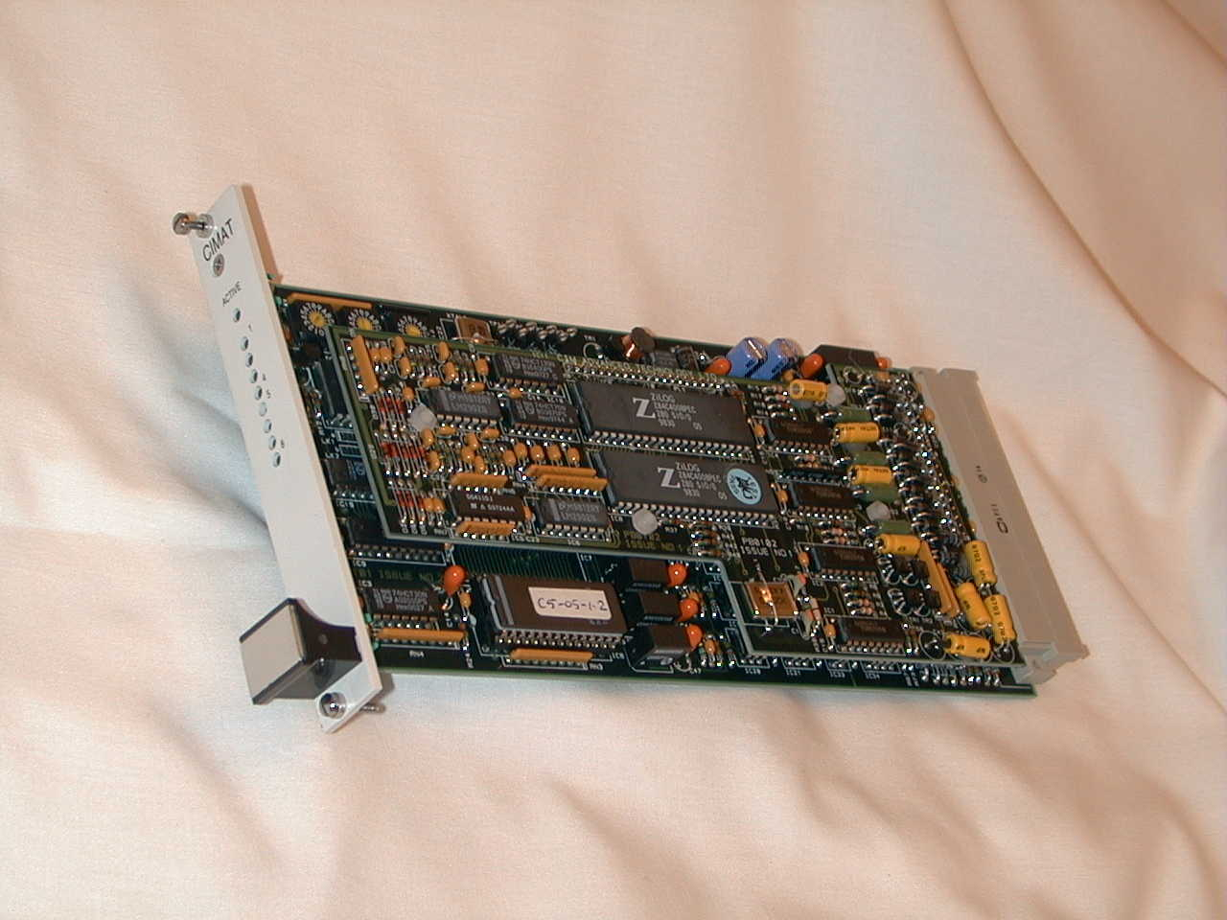
* 3 INDEPENDENT RS 485 SERIAL PORTS
(2 MODBUS ASCII & 1 MODBUS RTU)
* 3 ‘U’ HIGH 4 ‘HP’ WIDE SINGLE EUROCARD STAND-ALONE CARD
* UP TO 15 SMART TRANSMITTERS PER CHANNEL
* UP TO 21 CARD PER EUROCARD TRAY i.e. 1260 TRANSMITTERS PER TRAY
* DIN 41612 TYPE ‘F’ CONNECTOR.
NEEDS NO BACK-PLANE.

DESCRIPTION

The CIM 5300 series of cards provide an interface between HART or Honeywell DE transmitters and other equipment such as DCS, Flow Computers or SCADA Systems. In fact, any computer that can accept MODBUS protocols can be interfaced successfully using the CIMAT 5310 cards.
Each card allows the full range of smart commands to be available for the user to re-range and calibrate remotely, from the computer.
The module communicates using three independent Multi-drop MODBUS serial links (RS 485) .
Up to 32 similar cards can be connected together on a serial highway at a distance of up to 1.5 Km’s.
The module connects digitally to 4 loops of transmitters. Each loop can either be connected across existing 4-20 mA analogue signals, allowing the existing analogue card (if any) to still operate or be used as a completely independent digital loop (HART only). When used as a pure digital loop, then up to 15 field transmitters can be connected per channel (only one if using DE transmitters as the DE protocol disallows the use of multi-drop transmitters.)
The on-board processor polls each device connected to the loop in turn. The data is then stored in the local data base. The module also makes changes to the field device settings as directed from the host device ,connected to the three serial data-links.
Each data-link operates completely separately from t he other serial data-links.
The host data-links are opto-isolated from the supply and from the other serial links.
The module acts as a Slave to the host system. Special software can be used to interface other protocols.
The module address and baud rate are selected by rotary switches on the module. Address range is 0 to 251 (Note: address 0 is the broadcast address).
HART transmiterrs can be multi-dropped-DE transmitters cannot.
When using only a single HART transmitter on a loop, this can be used simultaneously to communicate digitally to the CIM 5000 card and a conventional 4-20mA input.

Figure 1 - Mechanical Details

Using 4 off BELL 202 modems per card, the system can operate 4 independent Hart or DE Loops enabling each loop to scan the heads at ½ second per head or better.

Important Notes

Using I.S. transmitter heads will restrict the number of HART transmitters per loop to that specified by the manufacturer.

Only one Honeywell DE Transmitter head is permissible when using the DE protocol.

HART loops allow a single transmitter on a loop to be addressed simultaneously in both 4-20mA mode and digitally.

DE transmitters can be used either digitally or in conventional 4-20mA format.
Figure 2 -Typical configuration
Figure 3 -The system integration of upgraded HART transmitters with new Hart devices using existing 4-20mA input cards and a new digital network including a host computer.

